ENGLISH 110
Section B, Code: 32828
Tuesday/Thursday 9:30-10:45am

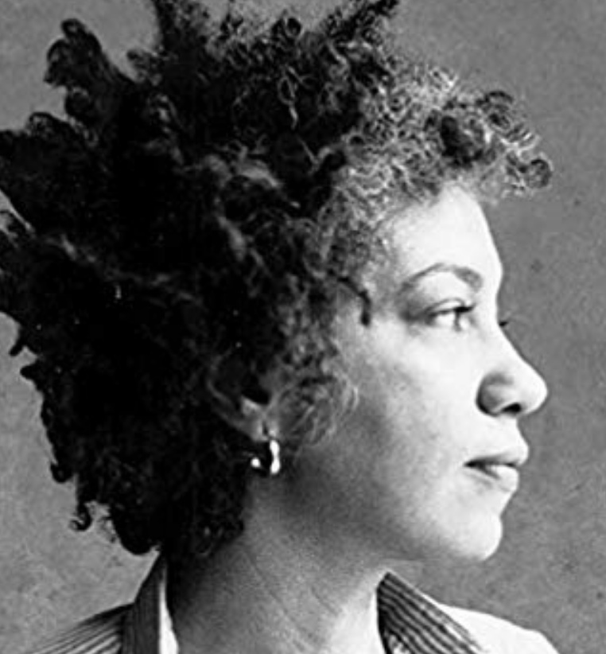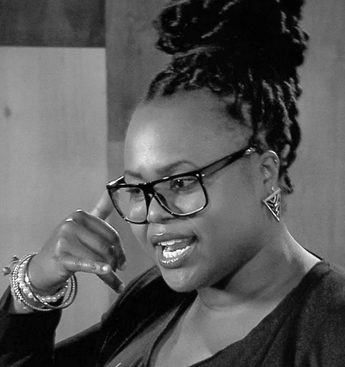

Instructor Details

Dilan Schulte  dschulte@ccny.cuny.edu Assignment email: engl110spring2021assignments@gmail.com
❖ IM me on Slack: #engl-110-spring-2021
Office hours will be held every Tuesday and Thursday, 10:50-11:30am. Stay after “class” or schedule an appt.
Course Website: https://dsenglish110.commons.gc.cuny.edu/
Course Description
Welcome to your first-year composition (writing) course! In this course, we’ll explore the connections between writing, reading, rhetoric, and critical thinking. You’ll practice writing for different purposes and audiences, and you’ll both give and receive substantial feedback on your and others’ writing. As learning from each other will be a large part what we do, you are expected to be an active participant in the classroom community.

Online Learning Format and Requirements
This course will run synchronously, which means will we meet regularly online as a group during our bi-weekly scheduled meeting times: Tuesdays and Thursdays from 9:30-10:45am. For the first five weeks of class, students will earn attendance credit by being present during those class meetings. Starting week six, however, students may opt out of attending our “live” classes, and they can instead earn attendance credit by 1) watching any recorded videos of our class session(s); 2) uploading notes on the class session(s); and 3) participating in any assigned Blackboard Discussions. All assignments, however, will still be due on the same days/times.

Course Topic of Inquiry
For the purposes of building our critical reading and thinking practices, we will engage several readings on a shared course topic of inquiry: “The Politics of Language.” We will explore questions such as these: What roles do language and literacy play in U.S. society? How do our language backgrounds affect our lived experiences and how we are perceived and treated by others? Who has access to literacy and who/what are the gatekeepers of that access? What are the historical and political implications behind how literacy education is valued and traditionally approached? What is the relationship between literacy and social differences, such as race and culture? How are we—the readers and writers participating in this class—affected by the ways that language and literacy function in the U.S.? We can understand this course as drawing on the topic of language and literacy as a vehicle for critically analyzing and developing our own languages and literacies.

Course Texts and Materials

This is a “ZERO Textbook Cost” course. As such, all materials will be accessible on Blackboard and Slack.
We will also read a collection of student writing (yours, your peers’, and others’). Please either print or have digital access to all course documents and materials for class.

Recommended Open Education Resources.
Use these additional resources as needed for help with the writing process, editing, and formatting.

https://www.wwnorton.com/college/english/write/fieldguide/index.asp
https://courses.lumenlearning.com/englishcomp1v2xmaster/
https://writingcommons.org/
https://owl.english.purdue.edu/owl/
https://writingcenter.unc.edu/tips-and-tools/

Online Technology and Software Requirements

You will need to regularly access
- Blackboard (CCNY’s online teaching support system where you’ll access and submit materials)
- Slack (an App you’ll download onto your mobile device, which we’ll use for day-to-day communications)
- Google Drive (a free online file storage site where we’ll share and collaborate on our writing)
- CUNY Academic Commons (where you’ll create a digital portfolio)
- Word-processing software of your choice: Microsoft Office, Office365 (available for free to CCNY students), Google Docs, etc. No matter what you use, please save all documents as .doc or docx files and please no links, PDFs, or Pages files.

I strongly recommend you make an effort to organize our course documents and your work. Create a designated “English 110 Spring 2021” folder on your computer and be strategic in how you use subfolders and title documents. You will need to return to assignments, so the more organized the better. Computers, as you know, are susceptible to crashing and freezing. Save your work frequently and back up your files (in multiple places!).

Course Learning Outcomes

In this course, you will work to

Recognize the role of language attitudes and standards in empowering, oppressing, and hierarchizing languages and their users, and be open to communicating across different languages and cultures.
- Explore and analyze, in writing and reading, a variety of genres and rhetorical situations.
- Develop strategies for reading, drafting, collaborating, revising, and editing.
- Recognize and practice key rhetorical terms and strategies when engaged in writing situations.
- Engage in the collaborative and social aspects of writing processes.
- Understand and use print and digital technologies to address a range of audiences.
- Locate research sources (including academic journal articles, magazine and newspaper articles) in the library’s databases or archives and on the Internet and evaluate them for credibility, accuracy, timeliness, and bias.
- Compose texts that integrate your stance with appropriate sources using strategies such as summary, critical analysis, interpretation, synthesis, and argumentation.
- Practice systematic application of citation conventions.

Grading

We will use a Grading Contract for this course. Please see our contract for details. In short, your grade will be based on attendance, submitting all minor and major assignments, and completing of the goals of each assignment successfully.

Major Assignments

You will complete four Major Writing Assignments, which are listed below and which will be described in more detail within an assignment prompt you’ll receive later. All parts of all major assignments must be successfully completed in order to pass this course. You will write multiple drafts and revise each major essay based on the peer feedback you receive. You will also receive extensive instructor feedback on your “Final” version, which you will then substantially revise again before including the “Portfolio” version in your Digital Portfolio.

# | Assignment Name | Length | Full  Draft Due | Final  Draft Due | Portfolio  Version Due
1 | Written Language & Literacy Narrative | 2.5-3 pages | Tue. 2/18 | Fri. 3/3 | Thu. 5/11
 | Spoken Language & Literacy Narrative | 3 minutes | Tue. 2/23 | Thu 2/25 | N/A
 | L&L Cover Letter | 1.5-2 pages | N/A | Fri. 3/3 | N/A
2 | Rhetorical Analysis Reports | 3-4 pages (6 max) | Thu. 3/16  and Tue. 3/18 | Tue. 3/23 | Tue. 5/13
 | REA Cover Letter | 1.5-2 pages | N/A | Tue. 3/23 | N/A
3 | Researched Essay | 5-6 pages | Tue. 4/20 | Thu. 4/22 | Tue. 5/6
 | RE Cover Letter | 1.5-2 pages | N/A | Thu. 4/22 | N/A
4 | Self-Assessment Essay | 3-4 pages | Tue. 4/27 | Tue. 5/4 | Thu. 5/17
 | Digital Portfolio | Varies | Tues. 5/6 | Thu. 5/17 | N/A

Smaller (Homework) Assignments

Reading and writing assignments will be due twice a week (Tuesdays and Thursdays) by the start of our class time (9:30am). You should plan to spend about 10 hours per week on our course: 4-8 hours on homework and/or essay writing for this course and 2.5 hours of class meeting time. You will be asked this semester to read, annotate, take reading notes, keep a record of ideas, revisit in-class assignments, collaborate online with your classmates, and engage in a variety of research, writing, and revision assignments. I (your instructor) will review homework on a regular basis. Much of your grade depends on you submitting smaller homework assignments, so do take these assignments seriously. See the Grading Contract for details about late and make-up assignments. If there are extenuating circumstances (e.g., medical or other emergencies), please do not hesitate to contact me so that we can arrange a good time to talk and figure out a plan.

Course Policies, Procedures, and Pertinent Information

Contacting Your Instructor: I want to get to know you, and I take seriously my role in supporting your learning. I strongly encourage you to contact me and visit during office hours (or make an appointment). And I expect you to keep me informed about your work, your progress, your questions, and your problems, preferably BEFORE your grade is the central concern. Do not hesitate to email me to ask questions or send me important reminders.

Professional Courtesy: It’s essential that we are all courteous and considerate of each other at all times. As a group, we will represent diverse cultural, racial, linguistic, and gendered identities and abilities. We must all commit to honoring, respecting, and accounting for our differences. As your instructor, I am committed to this.

Online Meeting Expectations: Meeting as a group online is hard. The out-of-class distractions are higher and not everyone has the sort of space/resources that make meeting online feasible. To whatever extent possible, find some private/quiet space during meetings. I also ask that you please turn off all electronic devices that are not to be used during class time. Keep your “mute” button on if you’re not talking and, if possible, keep your video going so that we can see you. Please don’t hesitate to reach out if you’re worried about meeting online.

Participation: I care deeply about students being present and engaged in class, and I’ll do my best to make class meetings meaningful and useful. I ask that you come to class on time and prepared with all relevant readings or texts. I understand that everyone has different approaches to participation, so I welcome you to engage in class in a way that best fits you (by quietly but actively listening, writing in the chat, taking notes, asking questions, and/or offering comments). Everyone is required, however, to collaborate with peers during group work.

Language. Students are expected to take an active role in developing their writing and language. I recognize that students come from different educational, linguistic, and racial backgrounds and that it takes several years, not a semester, to develop English academic language uses, especially if English is a student’s additional (and not first) language. As your instructor, I am committed to adopting approaches deemed most effective by the fields of Second Language Writing and Composition and Rhetoric: I will provide ongoing feedback on your writing to highlight potential areas to revise/develop (including language uses), and I will refrain from penalizing you for your language.

The Writing Center: The CCNY Writing Center provides a supportive learning environment where students can have one-on-one tutoring sessions with experienced writing consultants. The Writing Center is available for virtual meetings. Students can schedule an appointment through the online booking system. This is a free resource available to all students and recommended for all writing assigned in this and other classes. Visit their website for more info http://www.ccny.cuny.edu/writing/ and to book an appointment.

Academic Integrity: All writing submitted for this course is understood to be your original work. In cases where we detect academic dishonesty (the fraudulent submission of another's work, in whole or part, as your own), you may be subject to a failing grade for the project or the course, and in the worst case, to academic probation or expulsion. For a more detailed description of the guidelines for adhering to academic integrity, see CCNY’s Policy on Academic Integrity on the college website: http://www1.ccny.cuny.edu/current/upload/Academic-Integrity-Policy.pdf As part of this course, we will discuss responsible source use practices.

Special Needs and Accommodations: There are several Student Support Services available for CCNY students. Check this website for more information: https://www.ccny.cuny.edu/sssp. If you believe that you need accommodations for a disability, please contact CCNY’s AccessAbility Center (Student Disability Services), https://www.ccny.cuny.edu/accessability or call (212) 650-5913 for an appointment to discuss your needs and the process for requesting accommodations. I am committed to accessibility; please do not hesitate to reach out to me so that we can determine ways to make this course accessible to you.

CCNY Quick Links and Other Resources
- IT Service Desk (where you can get your CCNY username, set up your email and password, and get access to CUNY Portal, CUNYFirst, and Blackboard): go to https://www.ccny.cuny.edu/it/help, email, servicedesk@ccny.cuny.edu, or call 212-650-7878.
- The City College of New York website: http://www.ccny.cuny.edu/
- CUNYFirst: https://home.cunyfirst.cuny.edu/oam/Portal_Login1.html
- Blackboard: https://www.cuny.edu/about/administration/offices/cis/core-functions/cuny-blackboard/
- CCNY Writing Center: http://www.ccny.cuny.edu/writing/
- CCNY Library: http://ccny.cuny.edu/library
- CCNY online databases: http://library.ccny.cuny.edu/az.php
- List of computer labs (including those with printers) at CCNY: https://www.ccny.cuny.edu/it/hours
- Free access to New York Times for CCNY students: https://myaccount.nytimes.com/verification/edupass
- Free software for CCNY students (including Word): https://www.ccny.cuny.edu/it/software_stu

